41.16: a) 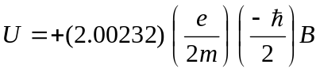
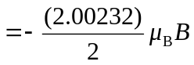
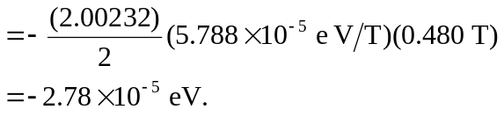
b) Since n = 1, l = 0 so there is no orbital magnetic dipole interaction. But if 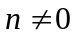 there could be since l < n allows for 